**Team 1**

**Deliverable 1**

Name: Vani Singhal

*Hypothesis A:* Participants’ age will negatively correlate with financial and material stability (the last two questions on the Flourishing Scale)

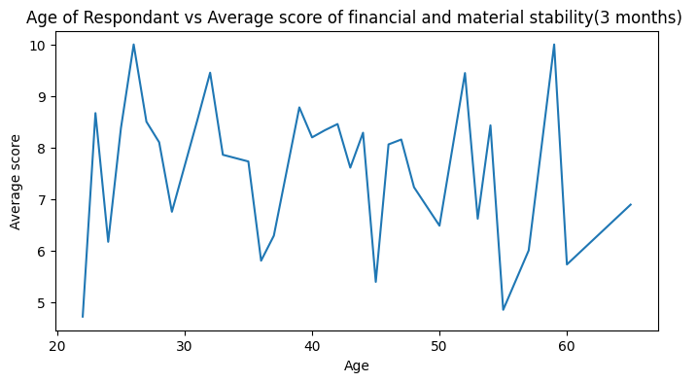

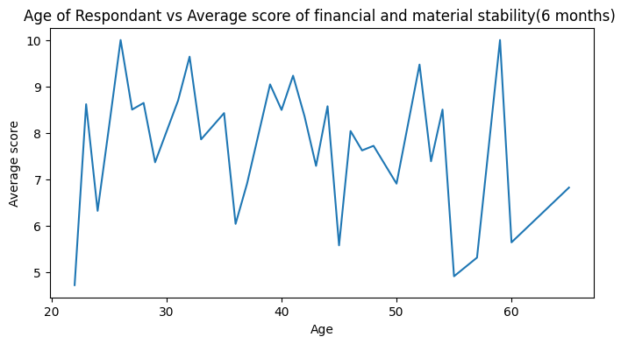

The graphs above show the relation between Age of participant and their average score of financial and material stability for 3 months and 6 months. There is not much of a difference between the graphs. Also, the hypothesis says that Age should negatively correlate with financial and material stability(Living Expense) but the graphs show there is no positive or negative correlation between them. So this hypothesis is clearly incorrect.

Name: Jessica Woo

*Hypothesis B: Participants who take an average of 4 breaks per day will positively correlate with productivity scores in the E-Work Life Scale (questions 16-20) and report lower discomfort at one month compared to six-month data.*

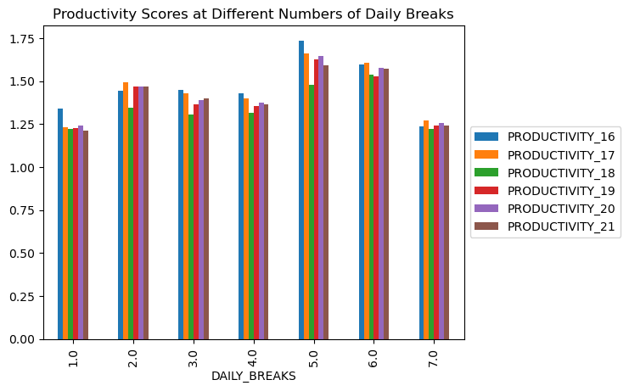

Yes, there is a positive correlation between taking an average of 4 daily breaks and productivity scores. The bar graph shows when participants take 4 daily breaks, the average productivity scores are between 1.0 and 1.5, which means that most participants reported better productivity (lower scores mean better productivity, higher scores mean worse productivity).

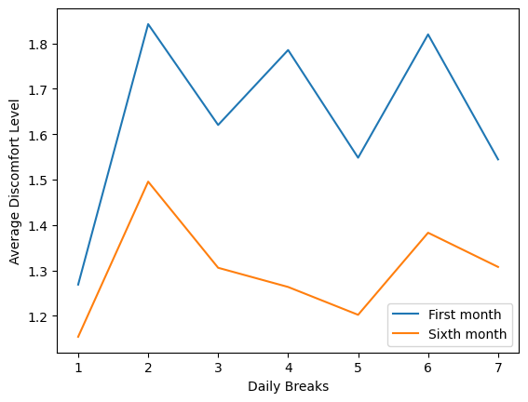

Yes, participants who take 4 daily breaks experienced a lower discomfort during the first month, but had a higher discomfort level during the sixth month. The graph also shows that there was an overall increase in discomfort from the first month of working from home to the sixth month. Participants who took 2 daily breaks and 6 daily breaks experienced the most discomfort.

Name: Ming-Han Hsieh

*Hypothesis C: Participants working in healthcare will have lower mental health scores on the Flourishing Scale than those working in other industries.*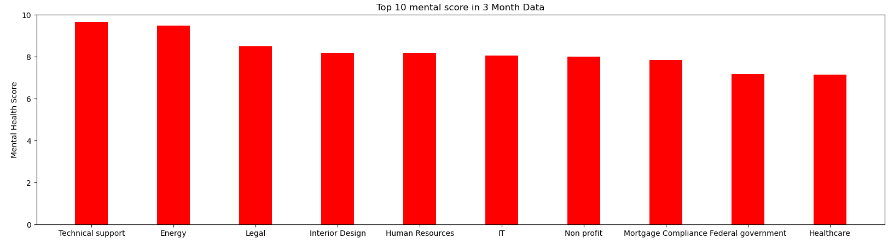

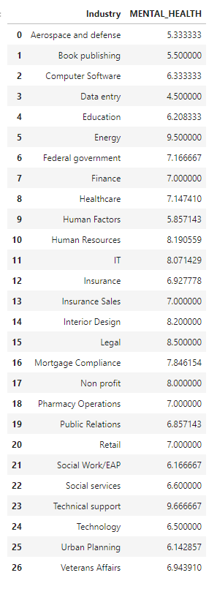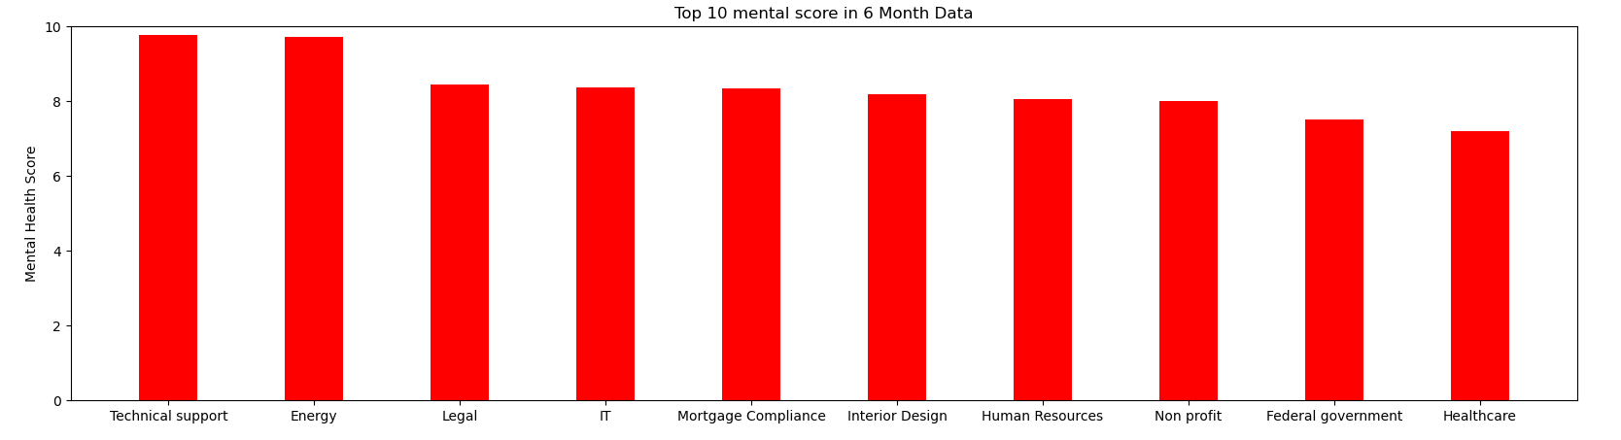

Totally, there are 26 unique industries in our dataset. We plot the top 10 industries that have the highest mental score. However, in both 6 month and 3 month data, we can observe that Healthcare has the 10th highest mental score in 26 industries. Therefore, we can confirm that the hypothesis is not valid. So maybe we take a look at what kind of jobs would really have the lowest mental score:

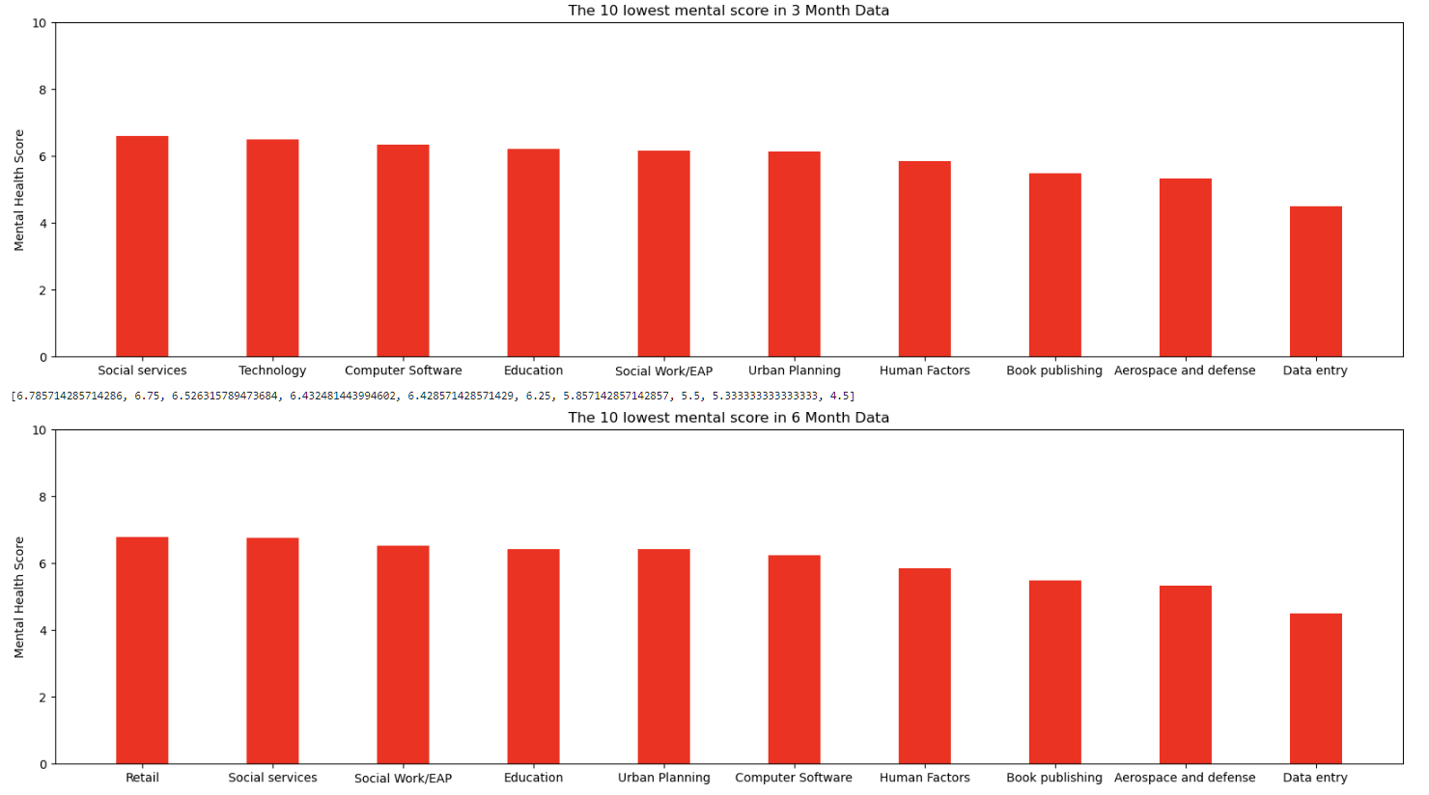

Here are the industries that have the lowest mental score. We can observe that the lowest mental score industry is Data Entry in both 3 month data and 6 month data.

Name: WEi-TSE KAO

Analyze and Answer iv. Where are people with their stress levels? Using the data from the Garmin watches as well as the survey data, are stress levels Increased, decreased, no change?

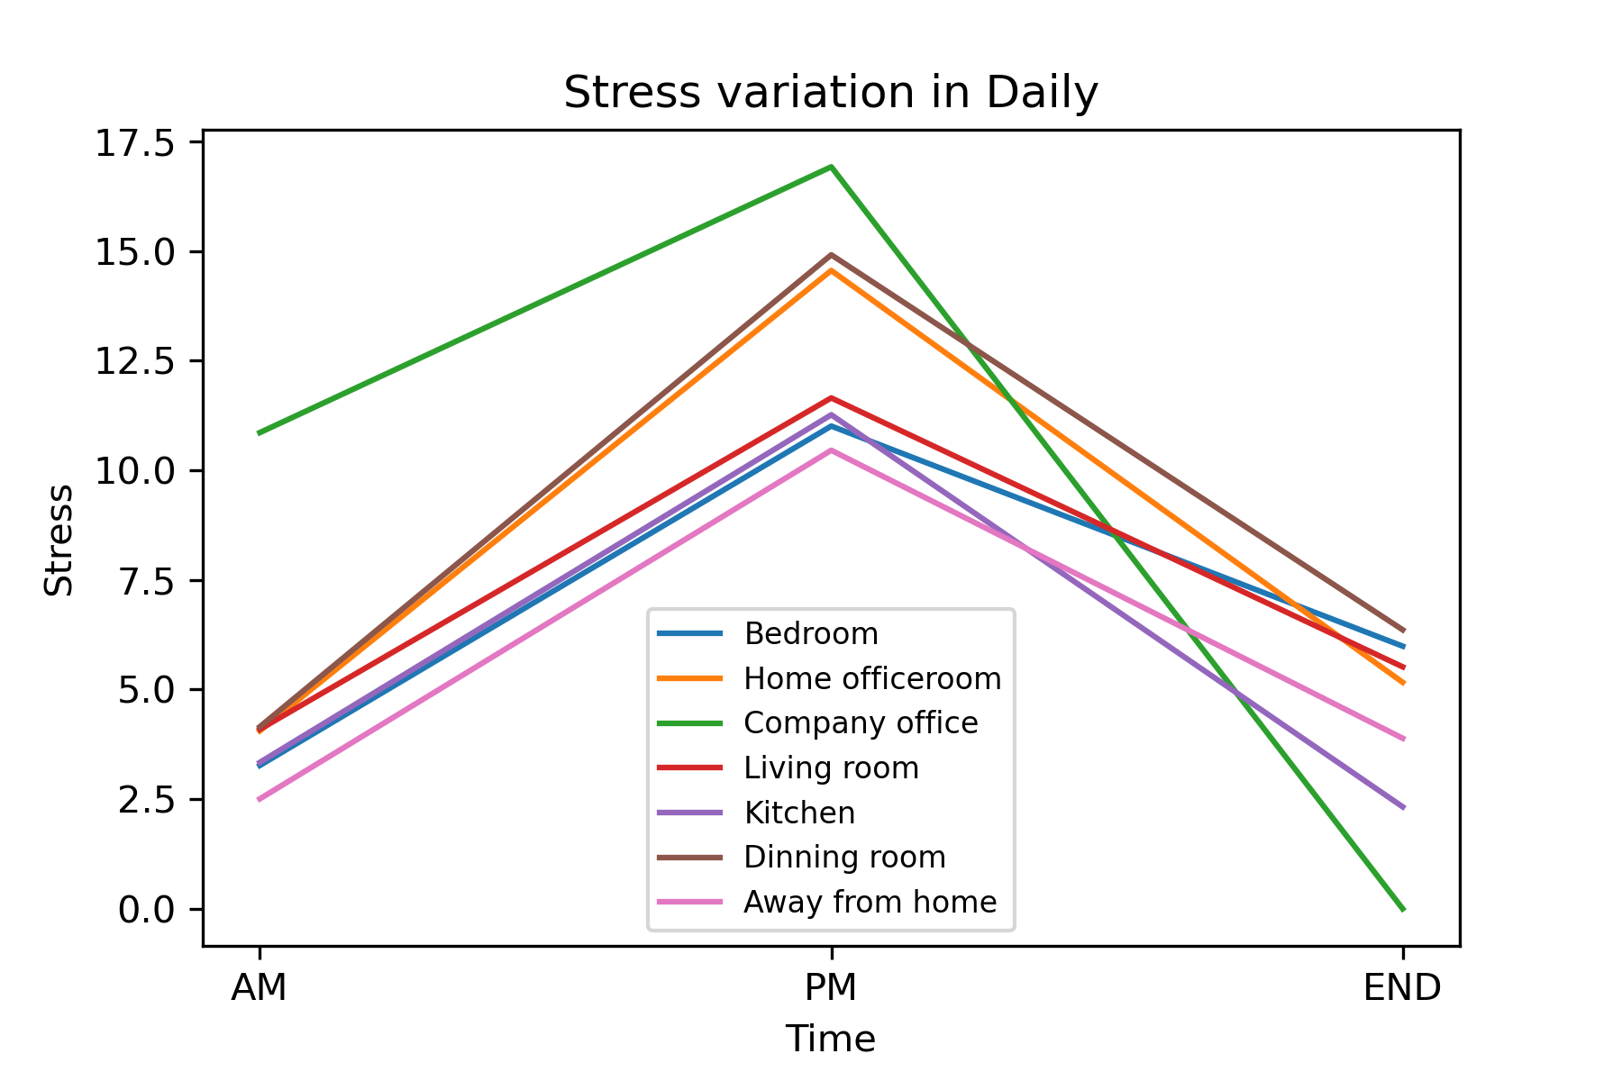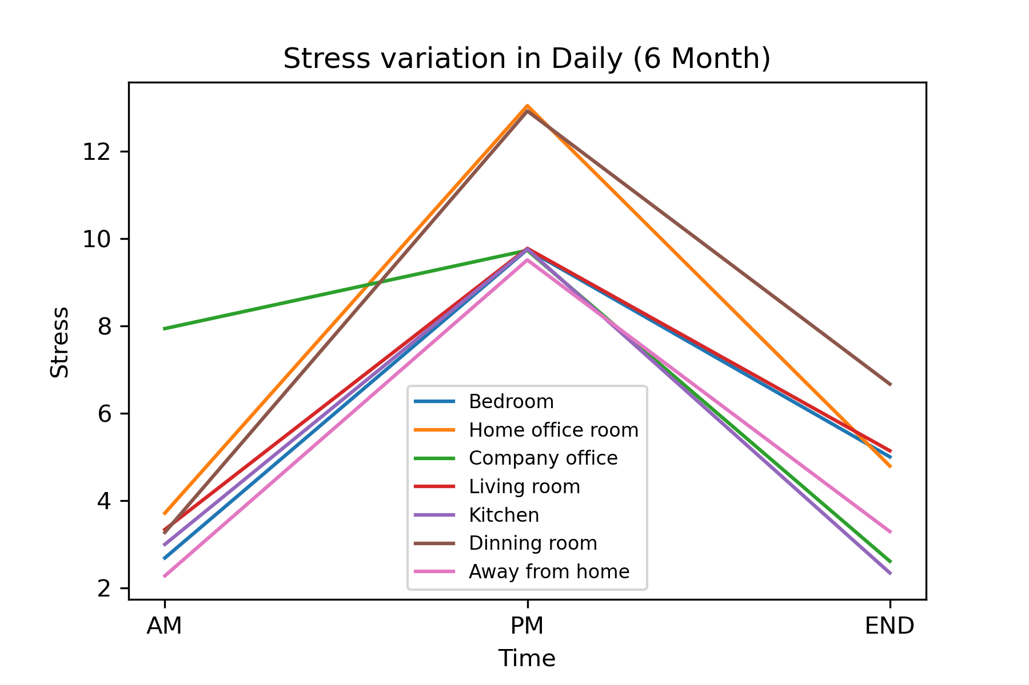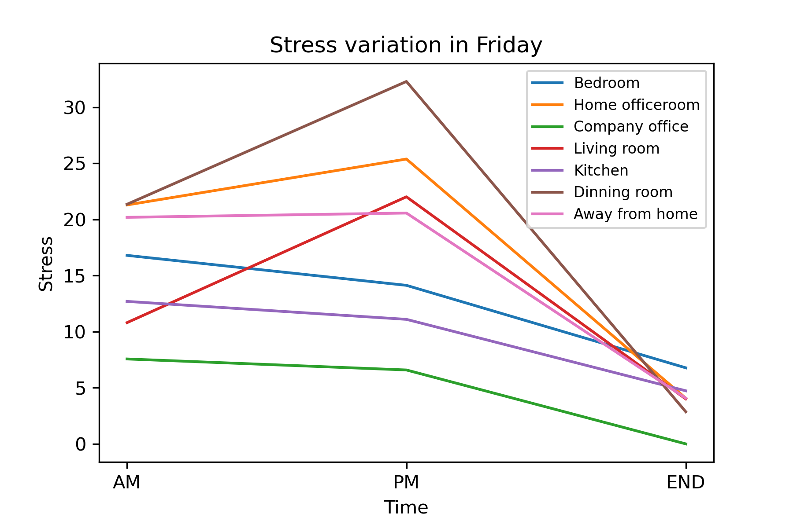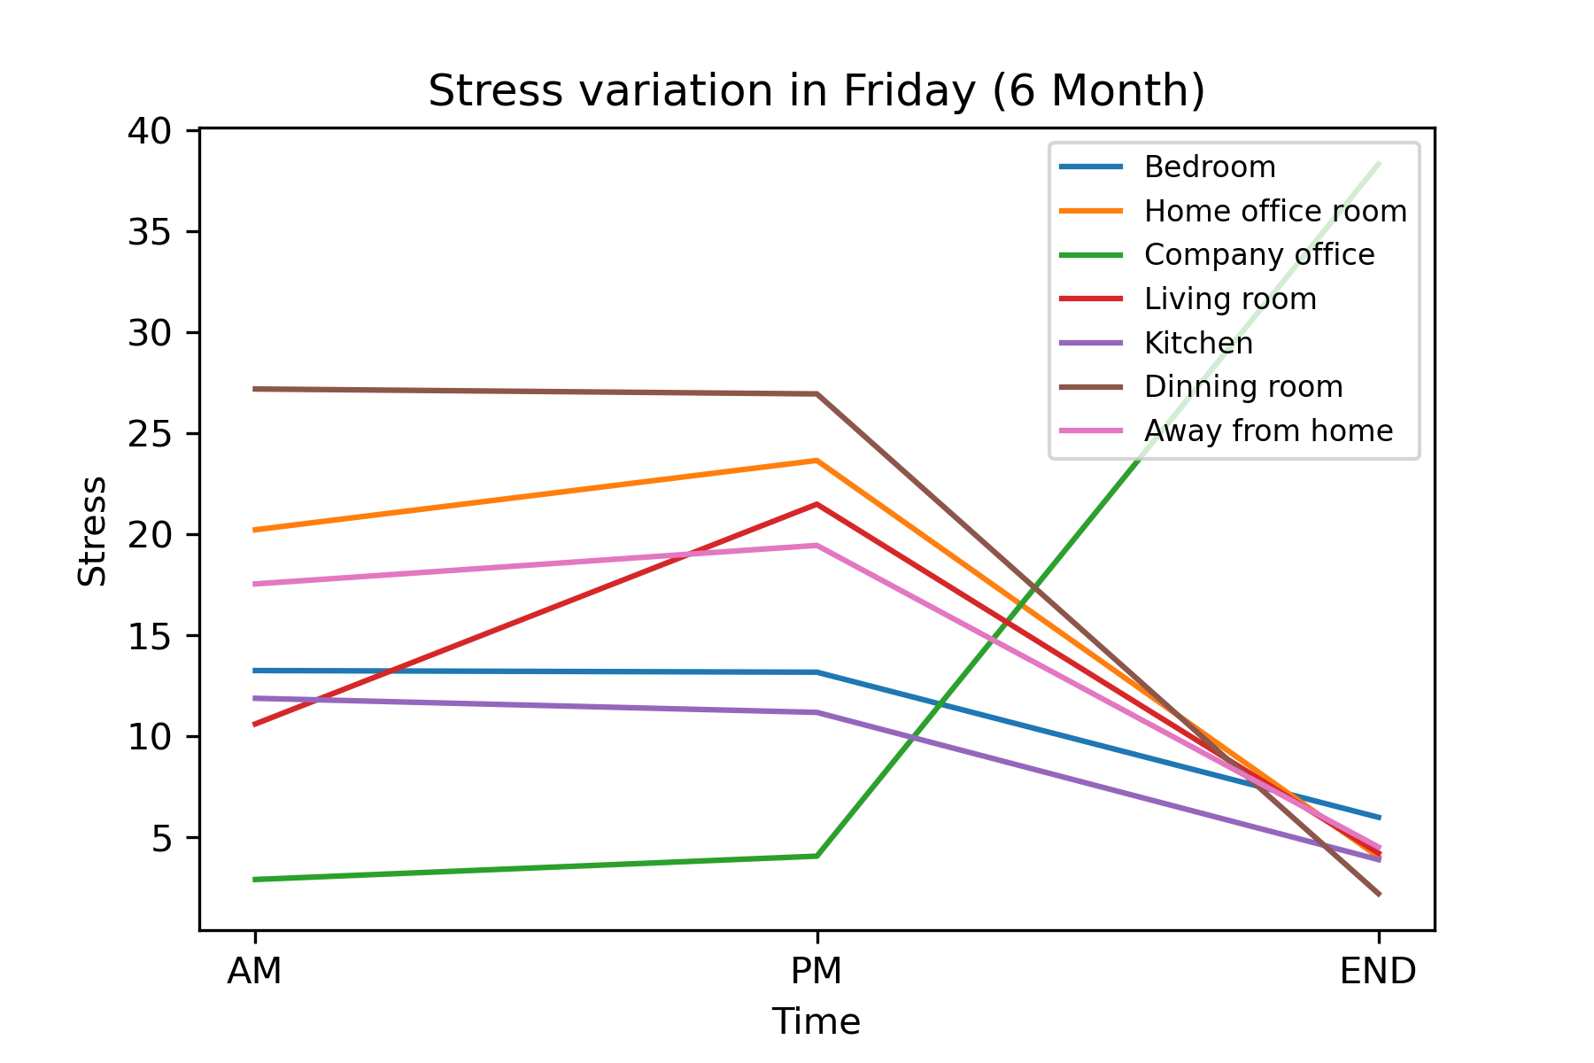

I utilized the “3 month” and “6 month” data in the day(“AM”, “PM”, “END”) including “Daily” and “Friday”, and analyzed them to plot line charts. We can observe the stress level of these locations.

In a day, the stress level will increase at “PM”, and decrease at the “END” of a day.

Comparing daily data in “3 month” and “6 month”, we can find that the stress level at “Home office room” decreases significantly, but the stress level of other locations doesn’t change apparently.

In “6 month data, we can observe that the stress level in Friday data doesn’t change significantly between “AM” and “PM”, and the stress level of all locations decrease at the “END” of the day except the stress level at “Company” office. However, I find that there is only one stress data at “Company office” in the dataset, so the result of the stress level at “Company office” in “6 month” day seems to be uneven.